**Sport for all at Lausanne Olympic Week**

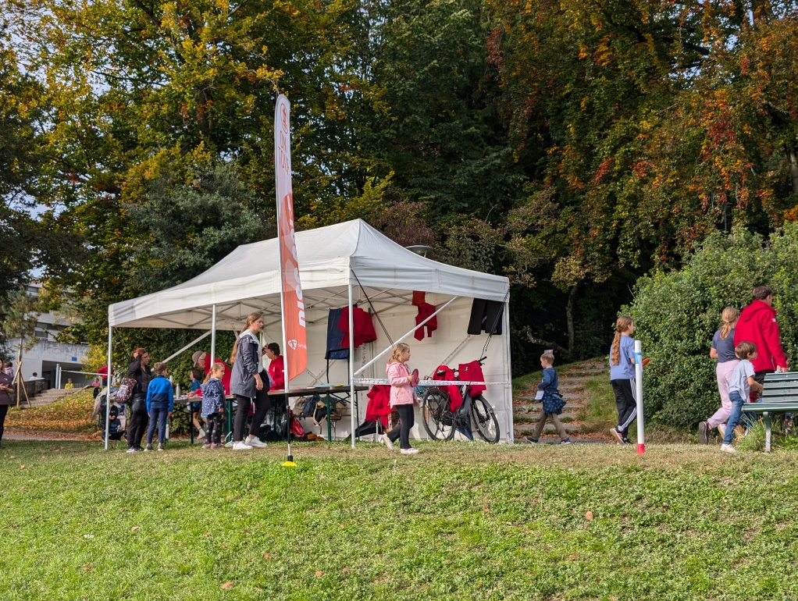Every year in October, Lausanne's Olympic Week brings together budding young athletes in the exceptional setting of the Olympic Museum, enabling them to discover over forty sporting activities free of charge. Aimed at youngsters aged 6 to 15, the event encourages the practice of sports through initiations, fun workshops and meetings with athletes and specialists. This year, for the first time, DiscGolf made its mark among the many disciplines on offer, thanks to the joint efforts of several clubs in French-speaking Switzerland.

Under the responsibility of the Saint-Cergue-based club DiscGolf La Côte (DGLC), in partnership with the Flying Bullets of Geneva and the Lausanne DiscGolf Association (LDGA), six days of initiation were organized on a course specially laid out for the occasion. Volunteers enabled over 1,000 children to learn this captivating sport, which demands skill and concentration. "It was an immense source of pride to promote our sport alongside such committed and passionate partners," emphasizes the DGLC president. "Without them, this extraordinary adventure would never have been possible. The Olympic Museum also expressed its satisfaction and hopes to host DiscGolf again next year.

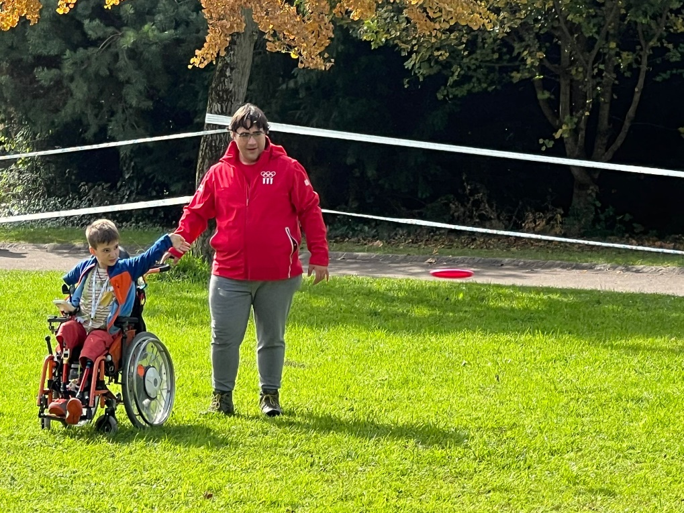The conviviality and inclusive spirit of this initiation event attracted many youngsters, including children with disabilities, proving that DiscGolf really is a sport for all. One participant in a wheelchair particularly impressed the volunteers with his enthusiasm. Despite the muddy paths, he participated with a radiant smile, and a few adjustments helped to make the experience suitable, such as helping him gain momentum with his wheelchair and adjusting his position for the throws.

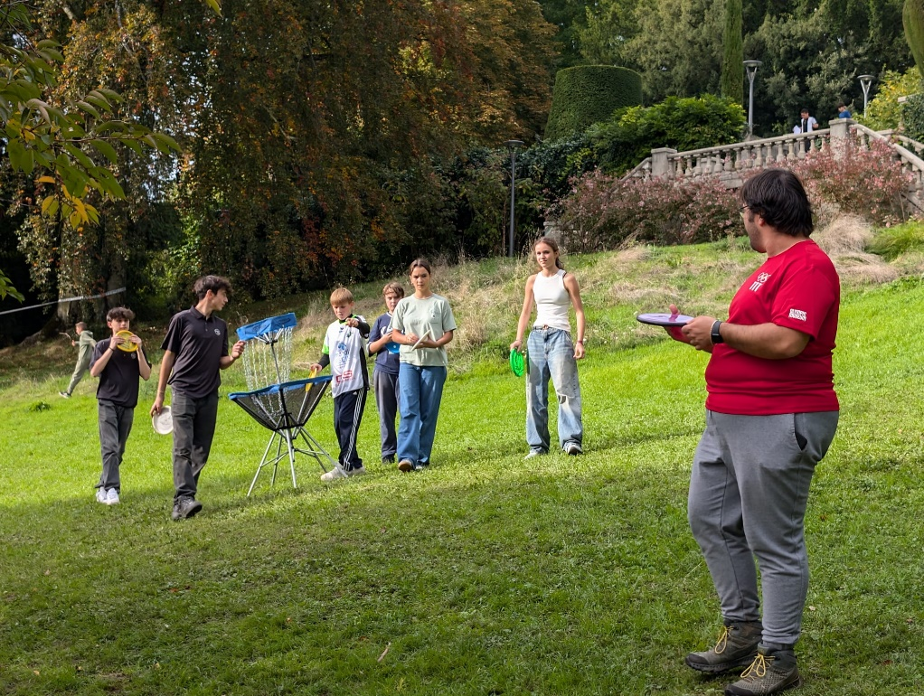Beyond the challenges of accessibility, the instructors also had the joy of seeing groups of children dubbed the "DreamTeam" form, returning every day to play. Thanks to the advice they received, these youngsters have acquired the basics of the game to the point where they can progress on their own on the pitch. There was one minor incident, when a disc accidentally hit another child's head, but the situation was well handled, and the incident in no way dampened the general enthusiasm.

For future editions, the DGLC plans to readjust the minimum age of participants to 8 to facilitate supervision, as the youngest, although motivated, proved more difficult to channel. This enriching experience showed that DiscGolf can captivate, teach and, above all, bring people together, making this Olympic week an unforgettable moment for all.

**Interview with the President of DiscGolf La Côte (DGLC)**

*(Journalist*): "Well done for a successful week! With so many participants, do you have any plans for future initiations?"

*(President)*: "Thanks for your enthusiasm! With the success we've had, we're fully motivated to organize as many introductions as possible in the four corners of French-speaking Switzerland and promote DiscGolf. But I'm taking advantage of the winter season to come back in force next spring, with lots of ideas and projects for the youngsters!"

*(Journalist*): "As Chairman, what was your most memorable moment of the event?"

*(Chairman)*: "Honestly, the passage of a young participant in a wheelchair was a particularly touching moment. His infectious joy, his enthusiasm for playing, and that beaming smile as he rattled the basket chains left a deep impression on me.

. This moment perfectly represented the spirit of DiscGolf that I'd like to promote: an inclusive, non-judgmental sport accessible to all. I started out in the sport in Geneva, and have evolved thanks to the inclusion and mutual support of Geneva clubs. This memory reminded me of the values that made me love DiscGolf, a sport that brings people together beyond their differences."

*(Journalist*): "You mentioned that you wanted to adapt the age of participants for the next edition. Why this change?"

*(Chairman)*: "This decision was taken following feedback from the instructors. We all noticed that the 6 and 7 year-olds were sometimes slowing down the groups, which could create gaps between the ages. The younger children were taking longer to reach the baskets, and this was reducing the enthusiasm of the older children. This is why we're considering either raising the minimum age to 8, or creating separate age groups with simplified starts for the younger children. This has yet to be defined, but the aim is to allow each age group to benefit fully from the experience."

*(Journalist*): "How does DiscGolf La Côte plan to continue promoting the sport in the region and among young people?"

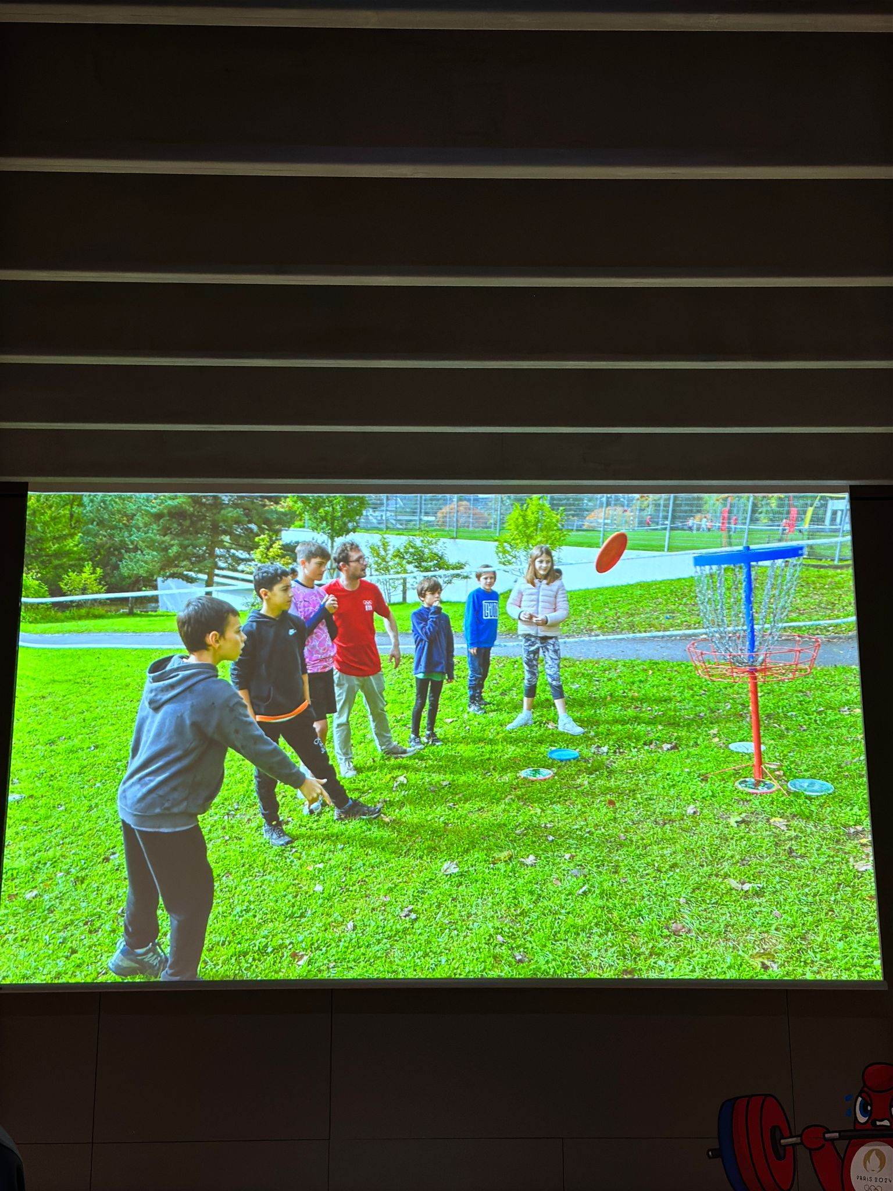*(President)*: "Our club wants to remain a bridge between Lausanne and Geneva for the development of DiscGolf. We take every opportunity to promote the sport, in particular by partnering with the town of Nyon and the commune of Saint-Cergue to organize events and introductions.  
In Nyon, for example, we offered a two-day introductory course at a multi-sport camp. As for Saint-Cergue, a more ambitious project is in the pipeline, although I can't say too much about it at the moment. We're also present at all village festivals, with baskets and discs to initiate young and old alike."

*(Journalist*): "What do you think makes DiscGolf unique compared to other sports?"

*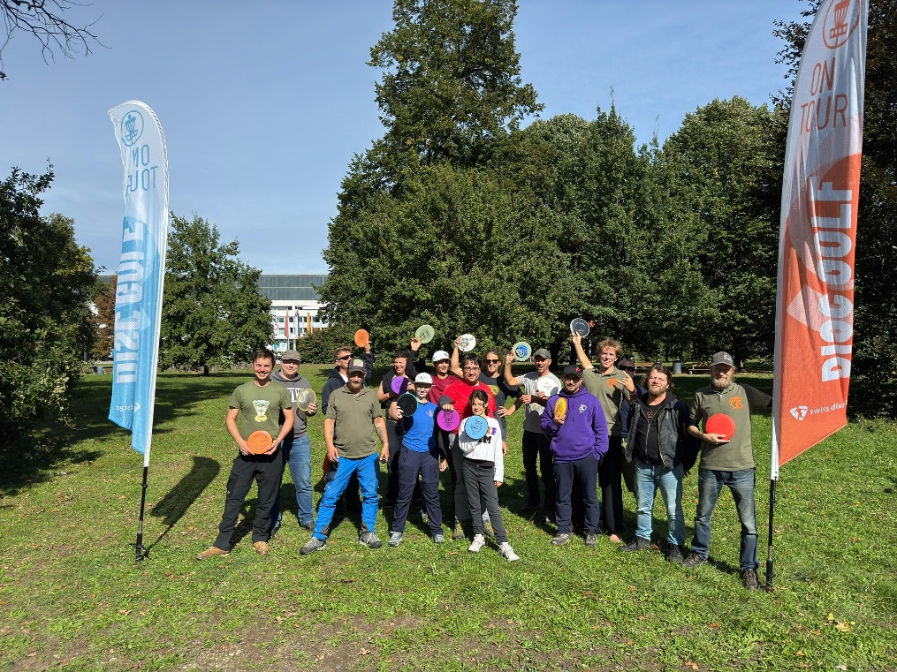(President)*: "Apart from the fact that DiscGolf, like all individual sports, requires a certain rigor, it's really its community spirit that makes it unique. Its mix is remarkable: men, women, children, seniors - there's something for everyone. We saw this year that even young people with disabilities can participate fully. It's a sport where inclusivity comes first, and for me, that's what sets it apart from the rest."

*(Journalist*): "Did you receive any feedback from participants that particularly impressed you?"

*(President)*: "All the instructors present would agree: the best feedback we got was from our "DreamTeams". These are groups of young people who came back every day with the desire to improve their performance. It touched us all deeply. We almost had to "fight" to accompany them, not to supervise them, but simply to play with them, so autonomous had they become. It was a welcome break from the intense week of initiations.

*(Journalist)*: "Do you have any special thanks to offer?"

*(Chairman)*: "Absolutely! I'd like to thank the Olympic Museum and its entire team for their warm welcome and their enthusiasm for our sport. Their support was essential in making this week a success. In addition, I'd like to express my gratitude to the volunteers and members of the partner clubs, in particular the presidents of the Flying Bullets and LDGA, who worked as instructors with exemplary commitment. Without them, this experience would not have had the same impact."